Blue Prism
Installation Guide – NHS Edition v4.2

April 2013

The information contained in this document is the proprietary and confidential information of Blue Prism Limited and should not be disclosed to a third party without the written consent of an authorised Blue Prism representative. No part of this document may be reproduced or transmitted in any form or by any means, electronic or mechanical, including photocopying without the written permission of Blue Prism Limited
© Blue Prism Limited, 2001 - 2013
All trademarks are hereby acknowledged and are used to the benefit of their respective owners.

Published by:
Blue Prism Limited
Centrix House
Crow Lane East
Newton-le-Willows
WA12 9UY, UK
Registered in England; Reg. No. 4260035
www.blueprism.com
Tel: 0870 879 3000
Contents
1 Introduction 5
1.1 Other Useful Documents 5
2 Pre-requisites 6
3 .net Framework 7
3.1 Description 7
3.2 Version 2.0 - Installation Instructions 7
4 Database 8
4.1 Description 8
4.2 Installation 8
5 Java Access Bridge 10
5.1 Description 10
5.1.1 Prerequisites 10
5.1.2 Installation 10
6 Microsoft Office 12
7 Blue Prism - Installation and Configuration 13
7.1 Installation Instructions – 32-bit 13
7.2 Installation Instructions – 64-bit 13
7.3 DNS resolution 13
7.4 Start and configure Blue Prism 14
7.4.1 Creating a database 16
7.5 Troubleshooting Installation / Initial Setup 17
7.5.1 Error Message 2869 on installation 17
7.5.2 Insufficient Permissions error message is displayed 17
7.5.3 Unhandled Exception entering System Manager in Windows Server 18
7.6 Log in and Enter License Key 19
7.7 Import the Microsoft Word Object 19
8 Scripted Installation Procedure 20
8.1 Installation of Prerequisites 20
8.1.1 Installing the .NET Framework 20
8.1.2 Installing SQL Server 20
8.1.3 Installing Java Access Bridge 20
8.2 Installation of Blue Prism 20
8.2.1 Installing Blue Prism 20
8.2.2 Configuring the database connection 20
8.2.3 Creating the Blue Prism database 21
8.2.4 Registering the License key 21
8.2.5 Importing Processes 21
8.2.6 Publishing Processes 22
8.2.7 Scripting References 22
9 Evaluation Guide 23
9.1 Overview 23
9.2 Open Process Studio 23
9.3 Produce the Automation Flowchart 23
9.4 Test and Run your new Process 27

Introduction
This document guides the new user through the process of installing the Blue Prism software suite for the first time, and gives some guidance on testing the installation.
In case of difficulty, please telephone Technical Support at Blue Prism – 0870 879 3000. Alternatively, email support@blueprism.com.

Other Useful Documents
A number of documents are available in order to provide more detail regarding specific aspects of the Blue Prism implementation. Please contact Customer Support for a copy.
- Blue Prism Infrastructure Data Sheet – Technical Specifications
A detailed explanation of supported operating systems, databases and hardware for Blue Prism client and server installations
- Blue Prism Infrastructure Guide
A detailed overview of Blue Prism infrastructure templates, including architectures, failover and DR strategies, communication methods and virtualisation requirements
- Java Access Bridge Installation Guide
A detailed overview of the steps required to install the Access Bridge using the installer and manually, along with methods for verifying the installation.
- Blue Prism Security Data Sheet – Active Directory
A guide to integrating Blue Prism with Active Directory for user authentication
A number of other documents covering monitoring, credential management and Citrix are also available – please contact a Blue Prism representative for an exhaustive list.

Pre-requisites
Windows Version
 |  |  |  | BP Client | BP Server
95 |  |  |  | ✗ | ✗
98 |  |  |  | ✗ | ✗
2000 (SP4) |  |  |  | ✓ | ✓†
XP (SP2+) |  |  |  | ✓ | ✓†
Vista 32-bit |  |  |  | ✓ | ✓†
Vista 64-bit |  |  |  | ✓* | ✓†
7 32-bit |  |  |  | ✓ | ✓†
7 64-bit |  |  |  | ✓* | ✓†
2008 (R2) 64-bit |  |  |  | ✓* | ✓†
* Runs as 32-bit application † BP Server is not supported with NHS Licence
64-bit application integration using “invasive” techniques not supported
Microsoft SQL Server
2005  - Express  - Standard  - Enterprise |  |  |  | 2008  - Express  - Standard  - Enterprise | 2010  - Express  - Standard  - Enterprise
Microsoft .net
2.0, 3.0, 3.5, 4.0
HTML Automation
Internet Explorer versions 6,7,8,9 & 10 - 32-bit editions

.NET Framework
Check the “Add and Remove Programs” component of the Microsoft Windows Control Panel.
If version 2.0 or above of the .NET framework is already present then you may proceed to “Database”.

Description
Blue Prism requires at least version 2.0 of the .NET framework, which is a standard Microsoft component, installed on most Windows environments. For environments with version 1.1 only, .NET 2.0 must be installed.

Version 2.0 - Installation Instructions
If you have not done so already, then locate and run the Windows Installer 3.1 Re-distributable Package (WindowsInstaller-KB893803-v2-x86.exe), following the instructions on screen.
Locate and run the .NET Framework 2.0 Re-distributable Package (dotnetfx2.exe), following the instructions on screen.

Database
Blue Prism can use any SQL Server instance, including SQL Server Express, for the development environment. SQL Server 2000, SQL Server 2005 and SQL Server 2008 are fully tested in our quality assurance testing.
If an existing SQL Server instance is to be used, proceed to Java Access Bridge

Description
For local installations or technical tests, a small scale version of SQL Server, SQL Express, can be installed on the Blue Prism desktop client. SQL Server Express 2005 or 2008 can be used.
SQL Server supports 2 modes of authentication - "SQL Server authentication" requires a username and password; "Windows Authentication" uses the current Windows local or domain logon to authenticate its users. Blue Prism supports either of these modes; for simplicity, the example below uses SQL Server authentication.

Installation
Locate and run the Microsoft SQL Server 2005 Express Edition installer, using the notes below.
At the appropriate point in the wizard, un-tick the box that reads “Hide advanced configuration options” (see screenshot).
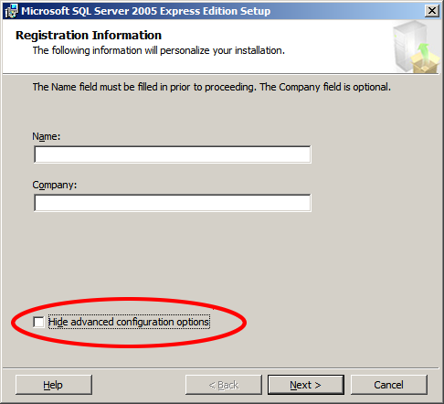
Accept the default values of the wizard until you reach the step with the title “Authentication Mode” (see screenshot). Choose to allow “mixed authentication mode”, in order that SQL authentication be available. Choose an appropriate password for the “sa” user, and make a record of it.
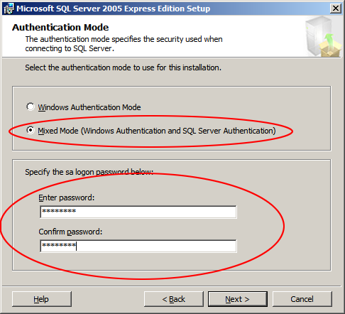

Continue through the wizard, accepting the default values. When finished, reboot if prompted.

Java Access Bridge
If any of the target applications are deployed using the Java Runtime environment (including browser plug-ins), then the Java Access Bridge is required to be installed on each Blue Prism client desktop.
If Java is not a target technology, proceed to Microsoft Office

Description
Blue Prism uses Java Access Bridge to access a series of specialised techniques for interfacing with applications written in the Java Programming Language
Further Reading: Java Access Bridge Installation Guide
For more information on installing the Java Access Bridge, a detailed overview of the steps required to install the Access Bridge using the installer and manually, along with methods for verifying the installation, is available from Blue Prism on request.
Blue Prism supports JAB version 2.0.0 for use with JRE version 1.2.2 and above. JAB 2.0.0 does not support 64-Java, so for 64-bit OS machines, please ensure you have 32-bit Java installed.

Prerequisites
The Java Runtime Environment (JRE) with which the Java Access Bridge (JAB) is to be used must be installed first.
Check the “Add and Remove Programs” component of the Microsoft Windows Control Panel.
If Java(TM) is already present then you may proceed to installation
Otherwise, proceed as follows:
Visit http://jdl.sun.com/webapps/getjava/BrowserRedirect?locale=en&host=www.java.com:80 and follow the instructions on screen.

Installation
Locate and run the BPJabInstaller.exe installation executable and follow the on-screen instructions. When complete, reboot your PC. It is an essential step to reboot your PC.
For environments with non-standard Java runtime installations, a manual installation is required.
Refer to the Java Access Bridge Installation Guide, available from Blue Prism Support, for details.

Microsoft Office
Microsoft Office is not a pre-requisite for Blue Prism.
However this document guides the reader through a test scenario in which Microsoft Word is used to verify the installation.
In order to complete the sample task, Microsoft Word will be required.

Blue Prism - Installation and Configuration

Installation Instructions – 32-bit
Locate and run the file BluePrism4.2.nn_x86.msi. Accept all default values in the wizard until complete.

Installation Instructions – 64-bit
Locate and run the file BluePrism4.2.nn_x64.msi. Accept all default values in the wizard until complete.

DNS resolution
It should be noted that Blue Prism resolves Resource PCs and the Blue Prism server by name, therefore it should be checked that the domains that the Resource PCs are running on are added to the Windows DNS search suffixes on the Virtual Machines / clients in order to ensure that they resolve correctly.

Start and configure Blue Prism
Start Blue Prism from the Windows start menu or desktop.
When you open Blue Prism on a computer for the first time, a message appears indicating that you must “specify a database connection before Blue Prism can function”.
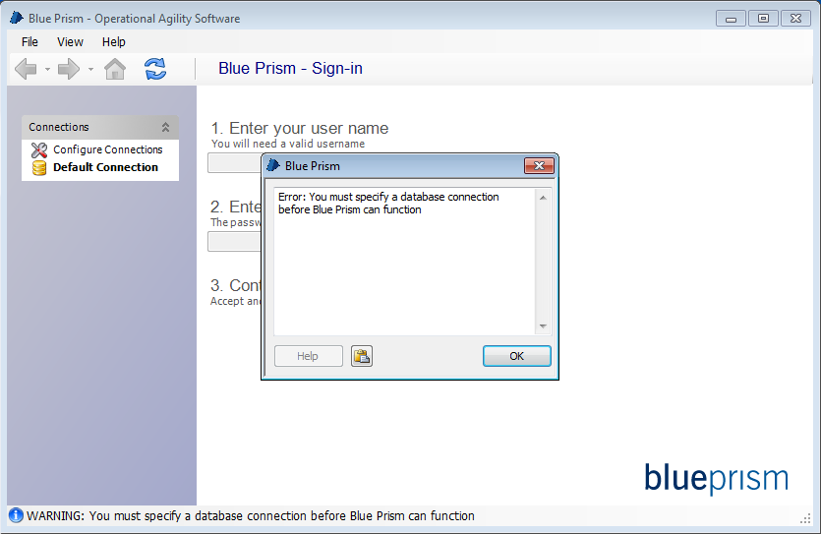
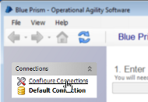
Choose Configure Connections in the Connections table on the left of the client window. Here we will create and configure the connection for Blue Prism to use.

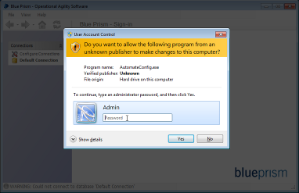

In Windows Vista or later, this action can only be performed by an administrator - an elevation prompt requesting admin privileges will display

Assuming that the windows privileges are present, the connection configuration window will display. Three connection types are supported:
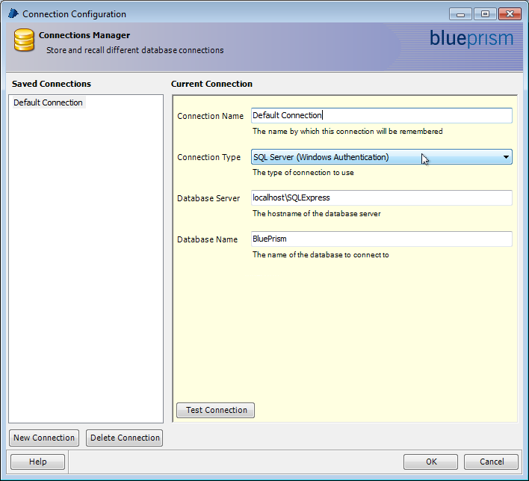
- SQL Server (SQL Authentication)
Connect to a named SQL Server instance using a saved User ID and password.
- SQL Server (Windows Authentication)
Connect to a named SQL Server instance using windows authentication. Note that database rules governing must be implemented on the database for the currently logged in user or user's group.
- Blue Prism Server
This option is not applicable to NHS licences - the server is not available for use.
Complete the form, ensuring that the authentication details are correct. Press 'OK' to save the data and return to the Blue Prism client.
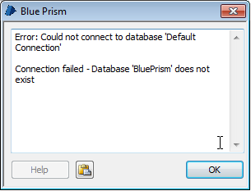
Assuming that the database connection was a direct 'SQL Server' connection and that it did not already exist, you should see an error message indicating that the database does not exist.
Any other message indicates that there is some communication problem between the client and SQL Server. The error message should provide some clues to indicate the cause of the problem.
Press OK to dismiss the message.

Creating a database
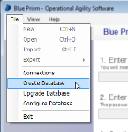
In the client, open the File menu and choose Create Database.
The Create Database window opens offering two methods for user authentication within Blue Prism:

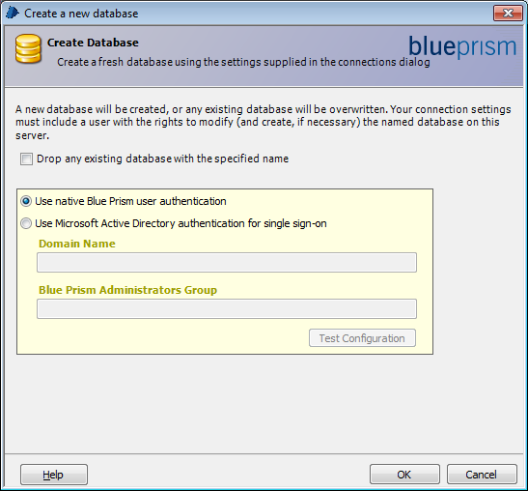
Native authentication
This is the only available option for NHS Installations. User accounts are stored and managed in the Blue Prism database. User accounts must be created individually for users (or shared as a generic login) within Blue Prism. There is no relationship with the current operating system user and, beyond a database / BP Server instance, there are no further external dependencies for this option.

Microsoft Active Directory for single sign-on
This option should not be used for installations which will use an NHS licence.
The single sign on functionality is not available in the NHS version of the product.
The Blue Prism user authentication mode must be specified in order to create the Blue Prism database and it cannot be changed on a database after the database has been created.

Troubleshooting Installation / Initial Setup

Error Message 2869 on installation
If, when installing over an earlier version of Blue Prism, an error message is displayed with an Error Code 2869, the earlier version should be uninstalled first. If, when attempting to do this, an empty error message box is displayed and the uninstall fails, the earlier version may have been corrupted by the aborted installation.
To fix this, enter the Add/Remove Programs applet in Control Panel, and Repair the Blue Prism installation. Attempting to uninstall Blue Prism should now work correctly, and the new version can be installed normally.

Insufficient Permissions error message is displayed
A message is displayed:
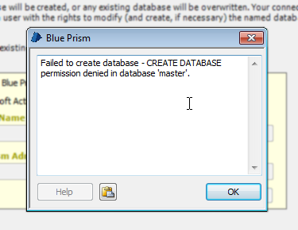
CREATE DATABASE permission denied in database 'master'
This indicates that the SQL user does not have permission to create a new database. This typically happens with Windows Authentication, but may occur with a SQL authenticated user with restricted power. A number of options are available for working around this issue:
- Giving the user the CREATE DATABASE permission in the SQL Server instance
- Configuring the connection to use a different login with the CREATE DATABASE permission
- Running Blue Prism as administrator may be enough to fix it. This only works if the Administrators group is given the dbcreate role in the SQL Server instance - something which occurs by default in SQL Server Express 2005, but not in later versions. To do this, find the Blue Prism executable, right-click it and choose Run as administrator. The executable is typically found at:
C:\Program Files\Blue Prism Limited\Blue Prism Automate\Automate.exe
- Asking a DBA to create the database. The database can be populated by the Blue Prism client using the Create Database command which will fill in the database with the Blue Prism tables.

Unhandled Exception entering System Manager in Windows Server
After installing on Windows Server, entering System Manager generates the exception:
System.TypeInitializationException: The type initializer for 'BluePrism.AutomateLicensing.clsLicensingRuntime' threw an exception. ---> System.InvalidOperationException: This implementation is not part of the Windows Platform FIPS validated cryptographic algorithms.
at System.Security.Cryptography.MD5CryptoServiceProvider..ctor()
at BluePrism.AutomateLicensing.AuthorisationDetails.GetCheckSum()
at BluePrism.AutomateLicensing.AuthorisationDetails.FromLicenseKey(String A)
at BluePrism.AutomateLicensing.clsLicensingRuntime..cctor()
In order for the encryption used in the Blue Prism license to work correctly, the 'Enforce FIPS' policy within Windows must be disabled. This can be done by setting the local/group policy:
System cryptography: Use FIPS 140 compliant cryptographic algorithms, including encryption, hashing and signing algorithms
to Disabled.
If this is not possible, a workaround is available to fix this within Blue Prism only. Create an XML file with the contents:
<configuration>
<runtime>
<enforceFIPSPolicy enabled="false"/>
</runtime>
</configuration>
and copy it into the Blue Prism installation directory. It will need to be copied several times to affect all of the Blue Prism executable files. It should be saved with the following filenames :-
    - Automate.exe.config
    - AutomateC.exe.config
    - BPServer.exe.config
    - BPServerService.exe.config

On running the application, System Manager should be available once more.

Log in and Enter License Key
By default a single user with the name “admin” is created on the new database - log in under this username, with the password “admin”.
You will be prompted to change the admin password to something more secure. Make a note of the new password that you enter.
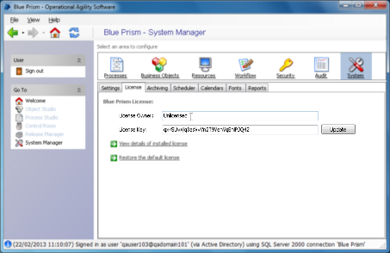
To install the license key, navigate as follows:
Click System Manager from the bottom of the navigation list.
Click System within System Manager. This is the right-most icon across the bar towards the top of the screen. Select the License tab
Enter your evaluation license details, including the License Owner and the License Key. Click the Update button and await confirmation that your key has been accepted.
The changes will be effected immediately after the license has been successfully updated.

Import the Microsoft Word Object
A Microsoft Word automation object is included with the release package, and must be imported into the Blue Prism database.
Sign in as admin.
From the main application window, select File…Import and browse to the BPA Object – MS Word.xml file provided with the release.
The files are usually located in C:\Program Files\Blue Prism Limited\Blue Prism Automate\VBO
Complete the wizard to import the object.

Scripted Installation Procedure
All of the above steps may be completed on the command line. These steps are provided merely as an alternative to the above procedure; you may skip this section if you have already completed the above steps.

Installation of Prerequisites

Installing the .NET Framework
To install the .NET Framework, run the following commands:
WindowsInstaller-v2-x86.exe /passive
dotnetfx2.exe /q:a /c:"install" /q
These commands can be safely called even if the respective components are already installed on the machine: each command will gracefully exit without doing any work.

Installing SQL Server
To install SQL Server, run:
sqlexpr.exe /qb ADDLOCAL=All SECURITYMODE=SQL SAPWD=****
This installs and configures SQL server for mixed mode authentication; the options "SECURITYMODE=SQL" and "SAPWD=****" may be omitted to configure for Windows Authentication only.

Installing Java Access Bridge
To install the Java Access Bridge, run:
accessbridge-2.0.exe /S /v /qn

Installation of Blue Prism

Installing Blue Prism
To install Blue Prism:
MSIEXEC.EXE /I "BluePrism4.0.11.msi" /QB- ALLUSERS=1

Configuring the database connection
Once the Blue Prism software is installed, the Blue Prism database connection may be configured. For SQL authentication mode, use:
Automate.exe /setdbname "DB Name" /setdbserver "DB Server" /setdbusername "DB User" /setdbpassword "********"
For windows authentication mode, use:
Automate.exe /setdbname "DB Name" /setdbserver "DB Server"

Creating the Blue Prism database
The Blue Prism database can then be created. For native Blue Prism authentication, use:
AutomateC.exe /createdb "*******"
(The password is only required if sql authentication is being used to connect to the database server.) Note that this time the AutomateC.exe executable is used rather than the Automate.exe executable.
For Active Directory authentication, use:
AutomateC.exe /createdb "*******" /setaddomain "Domain Name" /setadadmingroup "Group Name"
Again, the password after /createdb need only be supplied if sql authentication is being used to connect to the database server.
The current user must belong to the group specified under "Group Name". As a manual step, you must now sign in and configure the Single Sign-on groups’ configuration using the instructions above.

Registering the License key
The Blue Prism license can then be set:
AutomateC.exe /license "Owner" "keyABCDEFG12345678"
The license comprises two parts: the owner and the key. Each must be supplied on the command line in that order.

Importing Processes
Any requisite components can then be imported. This includes processes and business objects. Each is imported individually as follows:
AutomateC.exe /import "C:\My Process.xml" /user admin admin
AutomateC.exe /import "C:\My Object.xml" /user admin admin
The user credentials supplied here (username "admin" and password "admin") are the default options for native authentication; these have not yet been changed but will be changed later. Where Active Directory authentication is being used, the option "/user admin admin" should be replaced with "/sso"; this assumes that the Active Directory groups have already been configured.

Publishing Processes
Any processes which need to be published can be published as follows:
AutomateC.exe /publish "My Process" /user admin admin
Publishing a process makes it available to be run or scheduled.

Scripting References
The following table provides references to further information on the command line examples printed above.
Topic | Help Reference | Download Location
.NET Framework Redistributable | http://www.microsoft.com/downloads/details.aspx?FamilyID=0856eacb-4362-4b0d-8edd-aab15c5e04f5&displaylang=en | http://www.microsoft.com/downloads/details.aspx?FamilyID=0856eacb-4362-4b0d-8edd-aab15c5e04f5&displaylang=en
msiexec command | http://technet.microsoft.com/en-us/library/cc759262%28WS.10%29.aspx | n/a
SQL Express 2005 | http://msdn.microsoft.com/en-us/library/ms144259%28SQL.90%29.aspx | http://www.microsoft.com/downloads/details.aspx?familyid=220549b5-0b07-4448-8848-dcc397514b41&displaylang=en
Blue Prism Software | Please contact support@blueprism.com or telephone 0870 879 3000. | n/a

Evaluation Guide

Overview
This section provides a simple automation scenario in order to test the install.

Open Process Studio
Create a new process as follows:
- Click “Process Studio” from the left-hand navigation menu.
- Click “Create a new Process” on the resulting screen. A wizard will pop up.
- Enter the name “Letter Writing Test” for the new process.
- Enter the description “Evaluation test”.
Process studio will now appear.

Produce the Automation Flowchart
From the toolbar at the top, choose the “action stage” tool, as illustrated below:
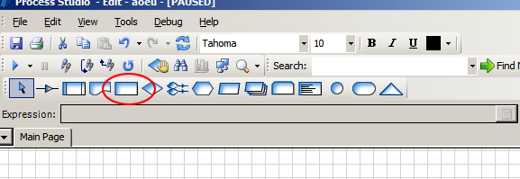
Place four action stages in a line on the diagram, equally spaced between the “start” and “end” stages, already present on the diagram (as illustrated below).
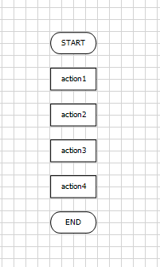
Double click the first stage (or right-click and choose “properties”). A properties form will appear.
Enter the name “Create new Document” at the top, and from the combo boxes below, choose the combination “MS Word VBO” and “Create Document”, as illustrated.
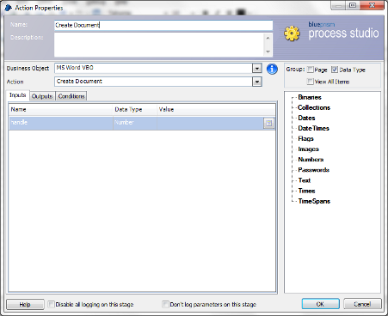
The inputs may be left blank
Click “OK” to save your changes and exit the form.

Repeat the same steps for each of the remaining stages, using the names “Show Document”, “Type some text” and “Exit”, as illustrated below.
In each case double click the stage and choose the “MS Word VBO” option, and from the second drop-down list choose the action which most closely corresponds to the name of the stage (namely “Show”, “Type Text” and “Exit”, respectively). Your diagram will now appear as follows:
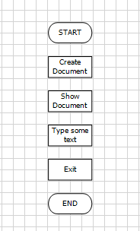
Double click the stage “Type some Text”.
In double quotation marks, specify some text to be written into the Microsoft Word document in the last column of the Inputs section for the text parameter.
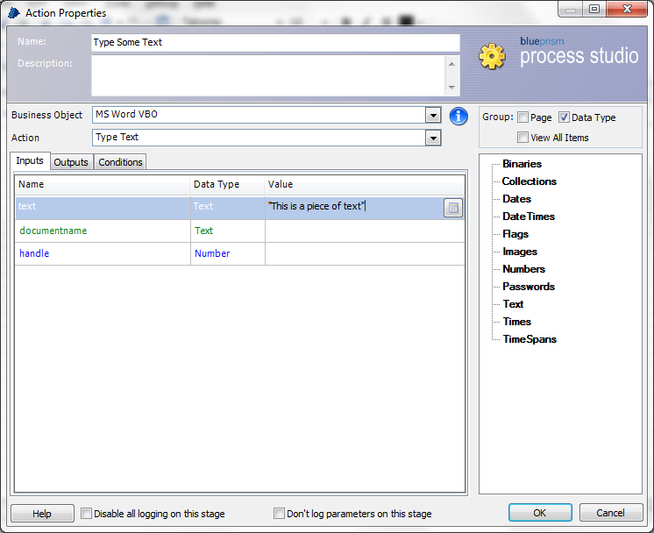
Be sure to enclose your text in quotes, as done in the example.
Click OK to return to process studio.
From the toolbar, select the link tool:
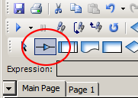
Use the mouse to link each of the stages in turn by dragging from one stage to the next. Your diagram should now appear as follows:
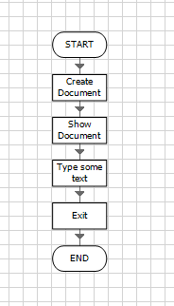
Finally, save your process from the “file” menu. Confirmation will appear in the status bar at the bottom of the window.

Test and Run your new Process
You can now step through your flowchart stage by stage and watch the Automation take place. The test makes use of the following toolbar buttons (named “Step” and “Reset”):
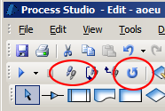
Proceed as follows:
Save the process if you have not done so already.
Click the “reset” button in the toolbar, circled on the right hand side of the screenshot above.
Click the “step” button in the toolbar, circled on the left hand side of the same screenshot. The first stage will be highlighted in orange. This indicates that it is the next stage to be run. Next time you click the “step” button, the actions contained in this stage will be performed.
Click “step” once more. This will cause the actions in the first stage to be carried out (namely to create a new Microsoft Word document). The document will be created “invisibly”, so you should not expect to see it appear yet (this is done in the next stage).
Continue to click “step”, to advance the process from stage to stage. Verify that the expected action takes place with each step (i.e. the new Microsoft Word document is shown, the correct text is typed into the document, and the document disappears on “Exit”).
If you wish to run the process again, click the “reset” button and repeat.

